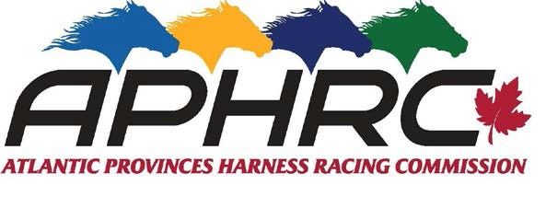
P.O. Box 128 Kensington, PE C0B 1M0
ATLANTIC PROVINCES BURSARY APPLICATION

Applicants must be Canadian citizens, an active member of Standardbred Canada or the spouse or child of an active Standardbred Canada member residing in one of the Atlantic Provinces. Applicants must have a passion for harness racing and demonstrate financial need. Applicants may or may not be pursuing a career in the harness racing industry. Students pursuing graduate degrees are not eligible.

Personal Information
Name: |  | Gender:
E-mail: |  | Phone Number:
Home Address:
City/Town: | Province: |  | Postal Code:
Date of Birth:
Parent’s Names:
Parent’s Occupations:
Number of siblings:
Number of siblings attending college or university:

Academic Information (Please include a copy of your most recent transcripts)
Current year in high school or post-secondary institution:
Community College or University you are attending or plan to attend:
Program you are currently studying or plan to study:
Career Objective:
Your grade point average (GPA):

Financial Information
Estimate your expenses for the coming year for the college or university that you plan to attend (please complete to the best of your knowledge):
Tuition:
Room / Board:
Books / Class Materials:
Transportation:
Other (explain):
Estimate how much money you will receive to cover the above expenses:
Parent’s Contribution:
Your Earnings / Savings:
Financial Aid:
Scholarships:
Loans / Government Grants:
How much Shortfall do you foresee?
Academic Achievements:

volunteer hours in the harness racing industry):
Volunteer Work
Please list and describe any type of volunteer work that you have been involved in within the past two years (including any
Harness Racing Participation
What is your background in harness racing?
What is your work experience in harness racing for the past 5 years?
Describe (in one sentence) how you feel about harness racing:

Typewritten Essay
Please attach a typewritten essay (no longer than 4 pages, double spaced in 11 or 12 pt. font) addressing the following:
Option 1:

Why do you love Canadian Harness Racing?
Please attach a minimum of two letters of reference from persons within the harness racing industry who know your level of involvement and background in the industry.

Submission Deadline is June 7, 2024.

Send application to:
APHRC
POBox 128
Kensington, PE
C0B 1M0
OR Email: cdoucette@atlanticphrc.ca

Winning recipients will be contacted by July 15, 2024.

- Successful applicants must agree to provide permission to have their name & photo published and used for publicity purposes.

- Successful applicants must provide confirmation of acceptance from their post-secondary institution prior to receiving monies.

